Summary of Announcements
Metro West Intergroup
July 2020

The first page lists the items to announce as brief bullet points; the second page contains more detailed information about each event. Let me know if you have any feedback about the announcement summaries: too detailed, not detailed enough, or anything else! Thank you for your service.

- Group Zoom hosting: To host your group’s Zoom meeting without Blair starting it, contact her for the MWI Zoom login and password. blairpoa@gmail.com

- Getting literature to newcomers while meeting online: Send a first name and last initial of interested newcomers to your MWI meeting to markfromnatick@gmail.com and he will mail the “Where Do I Start” newcomer pamphlet to them. Put “Newcomer Literature Request” in the subject line.

- Reading the MWI Strategic Goals at meetings
It is suggested to read the MWI Strategic Goals at meetings, to help all members be aware of ways they can practice the 12th Step. [see next page for the Goals]

- Reminder about not changing words when reading literature at meetings
AA General Service Office and OA WSO want to remind all meeting of the policy to not change any words when reading the Steps or Traditions, How It Works, or any other text from the Big Book.

- MWI Sunday Zoom workshops
  - 7/26/2020: 9am to 12pm: 12 Steps to a Positive Body Image. Cosponsored by MWI and the Nassau County and Suffolk County intergroups in NY.
  - TBA: 8/30/2020. Topic and Host are TBA. Contact Lisa Dee at info@metrowestoa.org. if interested in being a leader or have a topic.
  - Sunday Workshop coordinator needed for September and beyond.
Check the website for workshop updates at https://metrowestoa.org/latest-news/

- Region 6 Convention: the R6 Convention will be virtual this year, October 23-25. The latest information will be posted on the Region 6 website and Metrowestoa.org when available.

- Service Opportunity: Coordinator needed for online workshops starting in September.

- Returning to face-to-face meetings: When returning to in-person meetings, each meeting should update the OA.org meeting list, so MWI can update its list.

- For the latest updates on news, meetings, etc., always check the MWI website . metrowestoa.org

See next page for more detail.
- Group Zoom hosting: To host your group’s Zoom meeting without Blair starting it, contact her for the MWI Zoom login and password. blairpoa@gmail.com

- Getting literature to newcomers while meeting online: Send a first name and last initial of interested newcomers to your MWI meeting to markfromnatick@gmail.com and he will mail the “Where Do I Start” newcomer pamphlet to them. Put “Newcomer Literature Request” in the subject line.

- Reading the MWI Strategic Goals at meetings
It is suggested to read the MWI Strategic Goals at meetings, to help all members be aware of ways they can practice the 12th Step. The Goals are:
- Help members strengthen their personal recovery
- Increase the number of sponsors
- Increase the number of newcomers
- Increase the retention of newcomers
- Help those in relapse
- Inspire people to give more service
- Increase outreach and public information activities
If your group does not have an MWI meeting rep, please consider asking for a volunteer. Since meetings are on Zoom now, they may be more accessible to those living at a distance from Newton Wellesley Hospital.

- Reminder about not changing words when reading literature at meetings
AA General Service Office and OA WSO want to remind all meeting of the policy to not change any words when reading the Steps or Traditions, How It Works, or any other text from the Big Book. AA policy is that the text of A.A.W.S. copyrighted literature shall be presented as-is, with no amendments, changes or editing permitted.

- MWI Sunday Zoom workshops
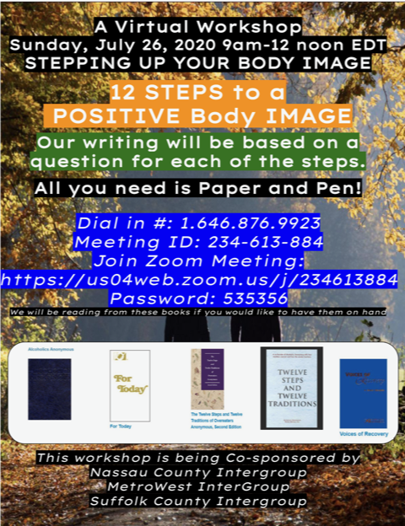
  - 7/26/2020: 9am to 12pm: 12 Steps to a Positive Body Image. Cosponsored by MWI and the Nassau County and Suffolk County intergroups in NY. Want to Step Up your body image? This workshop will involve writing based on a question for each of the steps. All you need is paper and pen. Dial in #: 1.646.876.9923. Zoom meeting: https://us04web.zoom.us/j/234613884, password 535356. Readings will be from the Big Book, For Today, Voices of Recovery, OA 12 and 12.

  - TBA: 8/30/2020. Topic and Host are TBA. Contact Lisa Dee at info@metrowestoa.org. if interested in being a leader or have a topic.
Check the website for workshop updates at https://metrowestoa.org/latest-news/

- Region 6 Convention: Focus on Recovery: The R6 Convention will be virtual this year, still on October 23-25. The latest information will be posted on the Convention website https://oaregion6.org/2020/ and Metrowestoa.org when available. There will still be great workshops and keynote speakers. The fundraising committee has a plan to do virtual raffles and is working on a virtual boutique “room” so Intergroups can also do fundraising. There will be lots of opportunities to get involved in service.

- Service Opportunity: Coordinator needed for online workshops starting in September. Contact Lisa Dee at info@metrowestoa.org if interested. You don’t have to lead the workshops, just find leaders and topics.

- Returning to face-to-face meetings: When returning to in-person meetings, each meeting should update the OA.org meeting list, so MWI can update its list. Group secretaries should consult with the meeting landlord to follow the facility’s guidelines. Groups can find information on social distancing guidelines at https://www.mass.gov/info-details/covid-19-prevention-and-treatment#latest-guidance- or https://www.cdc.gov/coronavirus/2019-ncov/community/index.html

- For the latest updates on news, meetings, etc., always check the MWI website . metrowestoa.org

